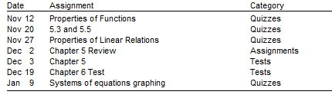

****All corrections must be made for full marks ****

