**Classifying, Estimating, drawing Angles**

**Classify and estimate the measure of each angle**

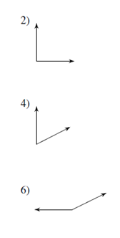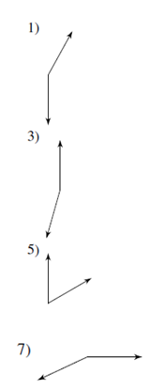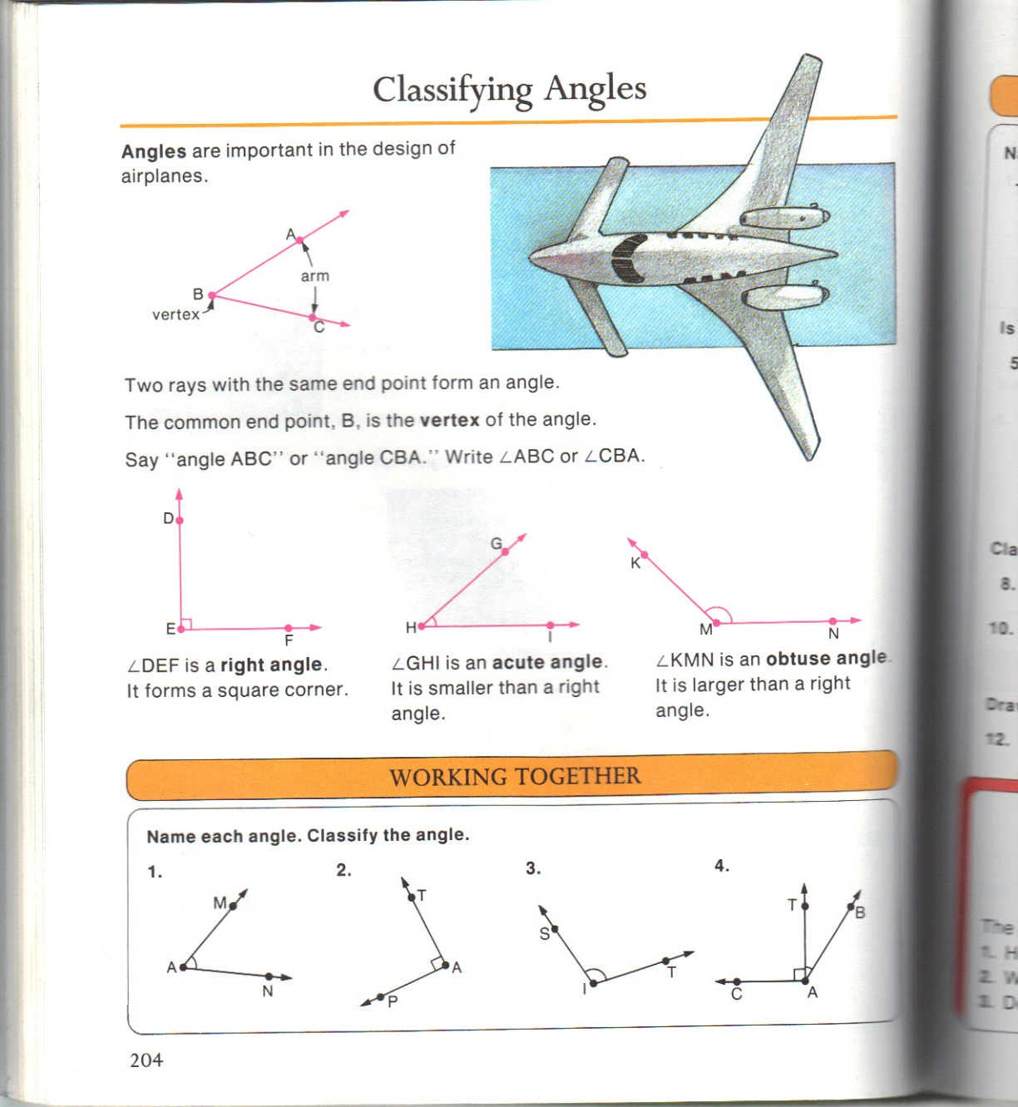

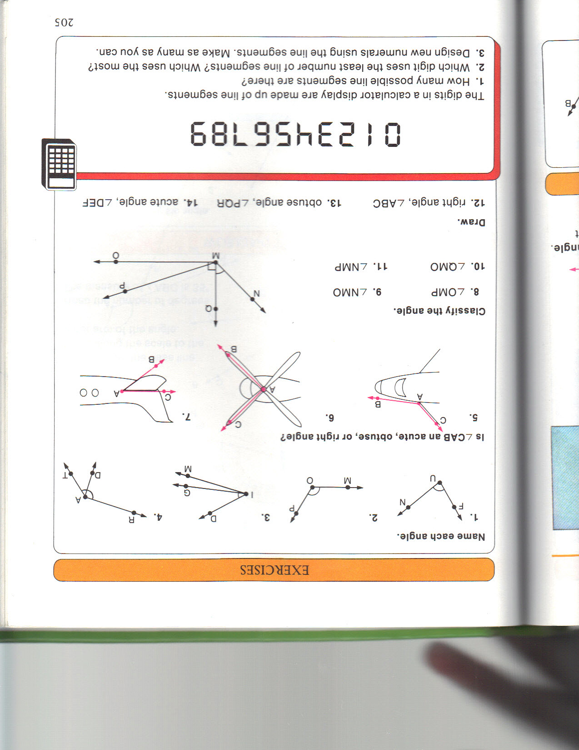

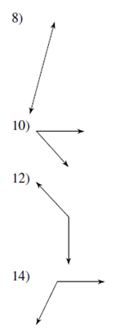

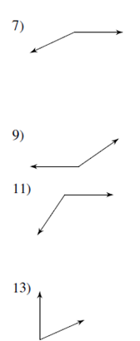

**Classify each angle**

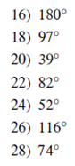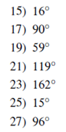

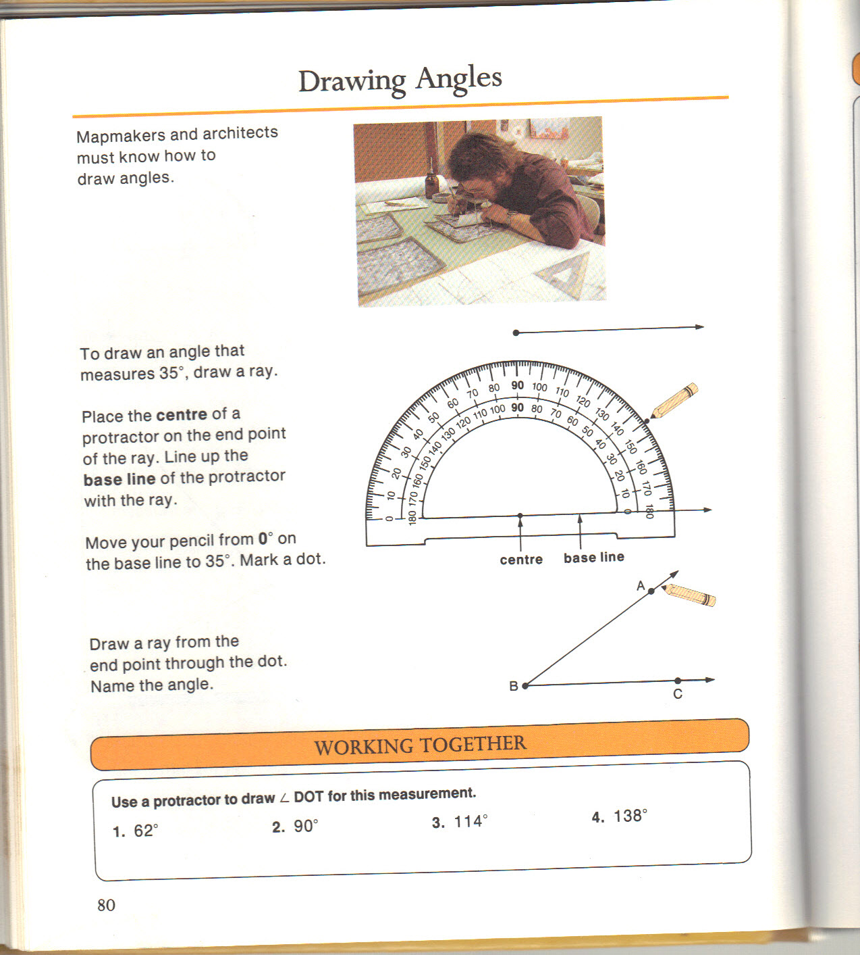

1. ______________

Measuring and drawing angles

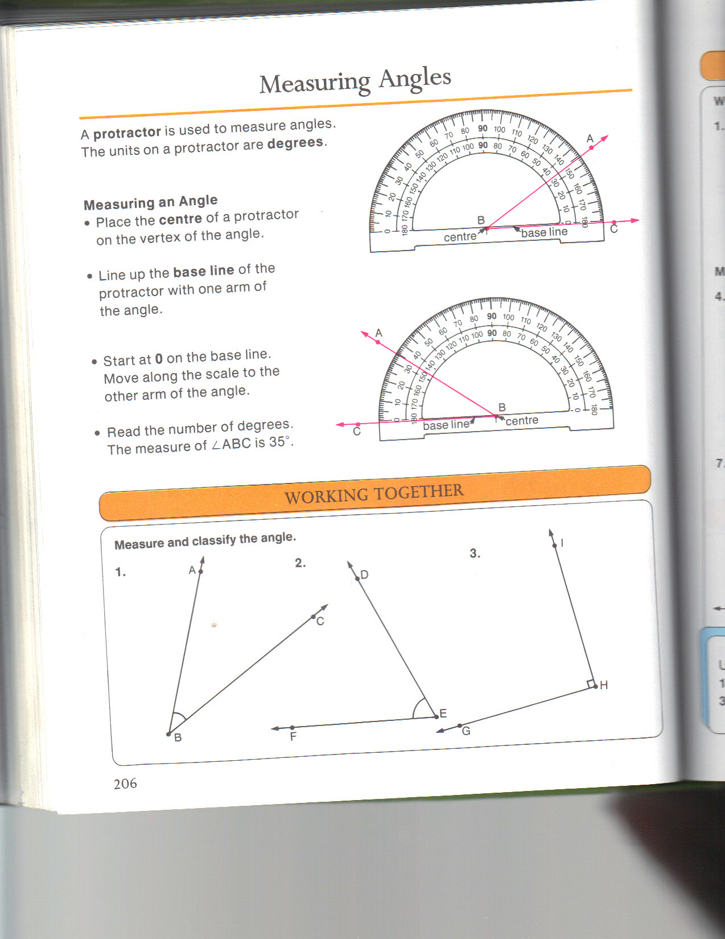

1. ______________
2. ______________
3. ______________

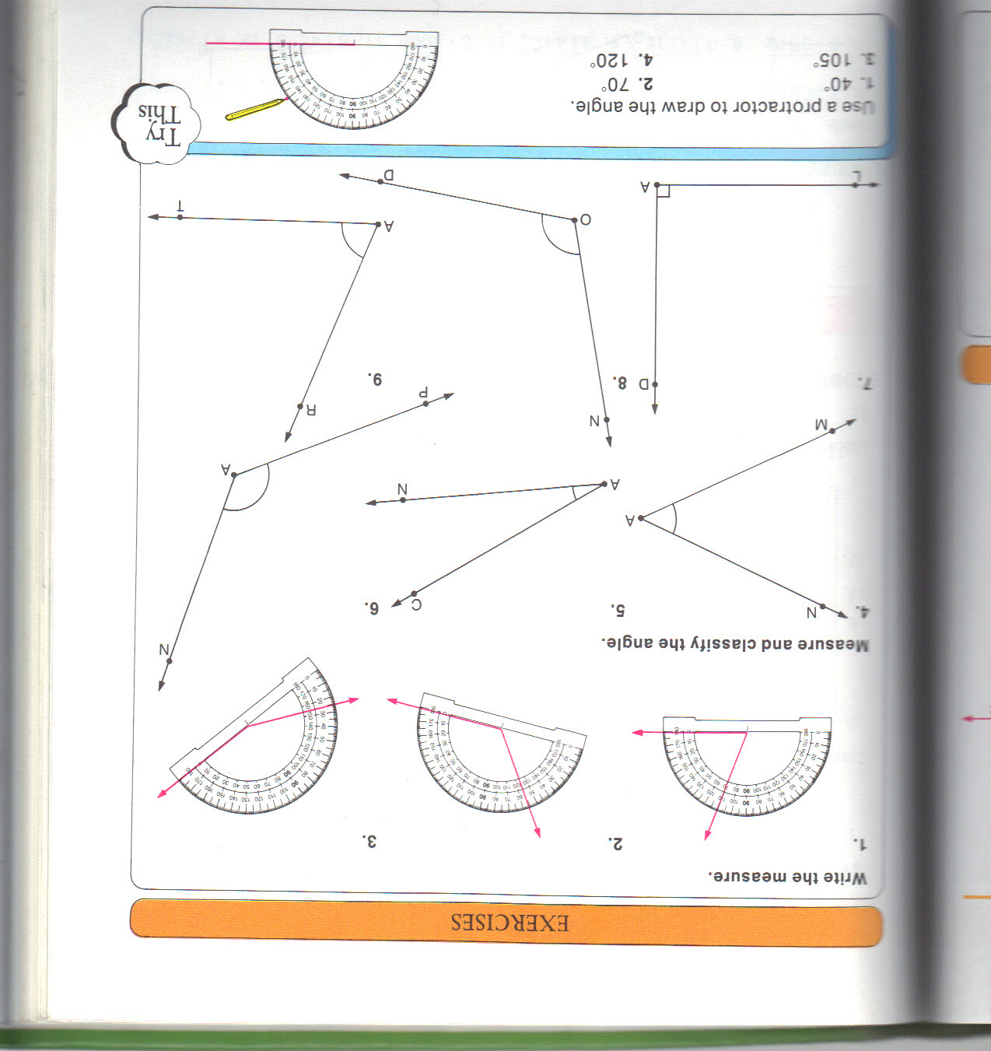

1. ______________
2. ______________
3. ______________
4. ______________
5. ______________
6. ______________
7. ______________
8. ______________

