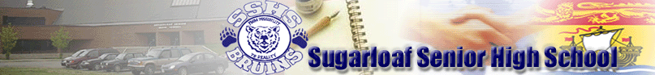
201 Dover Street, Campbellton, NB E3N 1R3 TELEPHONE: (506)789-2125 FAX: (506)789-2108
Principal: Mr. M. O’Toole Vice-Principal: Mr. J. Ryan

November 2nd, 2018

Dear Parents/guardian,

Our Student Advisory Council, along with the Sugarloaf Senior High School student body, will be giving back this Christmas. We are partnering with the internationally recognized group, Samaritan’s Purse, who runs Operation Christmas Child, to fill up shoe boxes with gifts for children in over 15 continents. This group, presided by Billy Graham’s son, Franklin Graham, brings these boxes to the children in developing and underdeveloped countries with the purpose of initiating conversations with local governments and piloting incentives to help members of these communities. One example of this is building fresh water wells for communities. This being the organization’s 25th Anniversary, we, as a united Sugarloaf Senior High School body, would like to take part in providing gifts for these children.

November 14th is the deadline for submitting items. Let’s fill up these shoe boxes! Let’s give back!

Suggestions for items to bring for the shoe boxes:
Dolls | Stuffed animals | Crayons
Socks | Hair clips | Pencil crayons
Cars | Musical instruments | Notebooks
Puzzles | Jump ropes | Coloring books
Toothbrush | Bar soap | Pens
Washcloths | Combs | Pencils

You can purchase items specific to age groups, for gender, or general for children.
BOYS | GIRLS
2 – 4 years old | 2 – 4 years old
5 – 9 years old | 5 – 9 years old
10 – 14 years old | 10 – 14 years old

ITEMS YOU CAN NOT INCLUDE IN THESE BOXES:
Food/candy | Liquids (shampoo, cream, lip balm) | Toys guns/toy knives/war related toys
Toothpaste | Used items | Breakable items (glass, mirrors)
Deck of playing cards

Thank you for your help!

Michael O’Toole BA, BEd, MEd
Principal

