Visual Arts Personnel challenge #2
Select a candy bar wrapper:
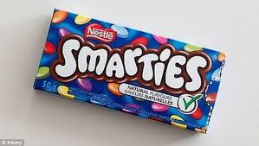
M&M, smarties, oh Henry… whatever your choice.
Draw the wrapper, and then create the color scheme as close to the wrapper as you can do. Send me your result.
Questions to answer:
- Explain what was the most challenging part of the drawing? Getting the image to look correct, getting the size (proportions) right?...
- Explain what drawing strategies you used to help you draw the image as accurate as possible? Did you use a grid design, use a ruler and measurements, did you trace?
- Explain what was the challenge in the colouring of the image?
- What would you improve in this project if you were to do it over again and why?

