Elements of Good Design
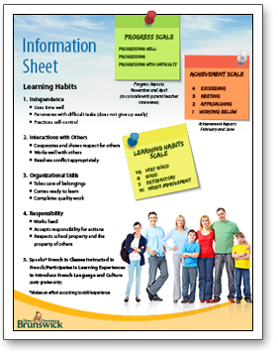
Once you know the message you want to express in your digital image or video, and who your target audience is, you need to consider how to design your product so it will get the attention it deserves.
The following pages of this module introduce four elements of good design:
- Contrast
- Repetition
- Alignment
- Proximity
In this course, we apply these principles to the visual aspects of design, such as images, text and graphics. You will learn principles specifically relating to sound later, in the audio module.
Understanding and applying these four elements can help improve your digital productions. Sometimes one element will be more important than another, and sometimes you may intentionally go against a guideline to achieve a special effect. The important thing is to consider each element every time, and make informed decisions as you create your final products.

Contrast
Contrast describes the sensation of difference within an image, graphic layout, video, etc. Consider the following examples of contrast:
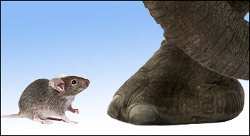
- A photo of a chunk of coal sitting amid a pile of snowballs: contrast in colour and value (darkness)
- A video close-up of dandelion seed heads that suddenly blow away when a race car zooms past: contrast in subject, movement, action
- A black-and-white photo shows a naked baby standing beside a spiny cactus: contrast in texture
- An image of African elephants' feet also shows one tiny mouse frozen in fear: contrast in size and power
Now, click on the links below to see examples and uses of contrast:
- Contrast in Design

Watch this video
https://www.youtube.com/watch?time_continue=2&v=IYWGLrYwzXo&feature=emb_logo

Contrast is a powerful design element when used effectively.
Look at the following examples and select the description that best describes how (or if) contrast is used in each one.

Question 1

The most effective use of contrast in this image is:
Question 1 options:
Contrast in texture
Contrast in colour
None. Contrast is not an important element.
Contrast in size
Contrast in subject

Question 2

The most effective use of contrast in this image is:
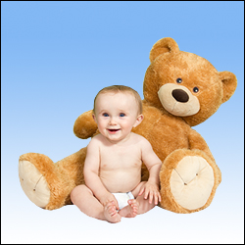
Question 2 options:
None. Contrast is not an important element.
Contrast in subject
Contrast in colour
Contrast in texture
Contrast in size

Question 3

The most effective use of contrast in this image is:
Question 3 options:
None. Contrast is not an important element.
Contrast in texture
Contrast in subject
Contrast in colour
Contrast in size

Question 4

The most effective use of contrast in this image is:

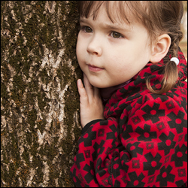
Question 4 options:
Contrast in subject
None. Contrast is not an important element.
Contrast in texture
Contrast in size
Contrast in colour

Question 5

The most effective use of contrast in this image is:
Question 5 options:
Contrast in size
Contrast in texture
Contrast in colour
None. Contrast is not an important element.
Contrast in subject

Question 6

The most effective use of contrast in this image is:
Question 6 options:
Contrast in size
Contrast in subject
Contrast in texture
Contrast in colour
None. Contrast is not an important element.
What were your answers? Is there only one good answer?

Repetition
Repetition refers to the appearance or intentional use of the same element more than once in an image, video, etc. Repetition means that one element turns up multiple times in the same work to achieve a particular result. Repetition is used to make a point.
Did you notice the repetition in the preceding paragraph? It does not make the paragraph read more smoothly, but it does emphasize the concept of repetition. Notice that in the preceding paragraph, the repetition was not exact—the repetition is of information or a concept, not of exact words. Repetition can involve exact or similar copies of an element.
A slide presentation that uses a consistent screen template (design) and headline font is applying repetition. A photo of a long row of ducklings waddling down the sidewalk shows repetition.
Now, click on the links below to see examples and uses of repetition:
- The Use of Repetition in Design Read the article in this link
https://www.peachpit.com/articles/article.aspx?p=2268752

- Using Repetition and Patterns in Photography Read the article in the link
https://digital-photography-school.com/using-repetition-and-patterns-in-photography/

Repetition Activity
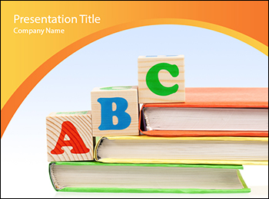
Repetition can add impact and a sense of predictability or rhythm to a work. It can even be used to add humour.
Examine the image above carefully to find examples of repetition.

Alignment
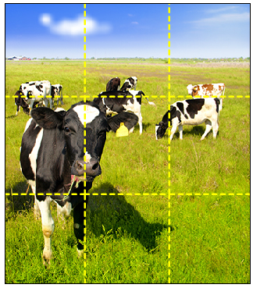
Alignment is the design element that says, "I carefully planned where every single part of this work appears."
In visual products, alignment refers to the physical location of design elements. Sometimes, alignment means that elements line up with each other. For example, the bullets and first letters of titles and each line of text might all line up vertically in a PowerPoint presentation. Other times, alignment might mean that design elements align with (are positioned near) specific locations on the screen, page or canvas. For example, photographers and painters often align the key elements in their images with imaginary guidelines described by the rule of thirds.
Follow the link to read about the rule of thirds. Ignore the pop-ups
https://www.cambridgeincolour.com/tutorials/rule-of-thirds.htm
Now, to read more about alignment.
https://www.printwand.com/blog/basic-alignment-principles-in-graphic-design-with-examples

Time to get your ducks in a row and check your understanding of alignment. Answer the following questions to check your understanding.
Note: some questions have more than one answer.

Question 1

Which statement is the best description of alignment in this photo?
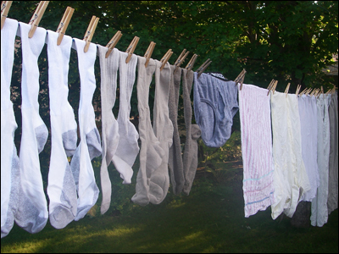
Question 1 options:
The clothespins line up, and so do the toes of the socks. Also, the bottom of the towels and
pants are parallel to the clothesline.
The trees make vertical lines, and you can see horizontal lines in the first towel and roof in
the background.
There is no alignment because nothing lines up horizontally or vertically.
The clothespins are the only thing that lines up. Everything else is just random.

Question 2

What one change would make the best improvement to alignment in this page
layout?
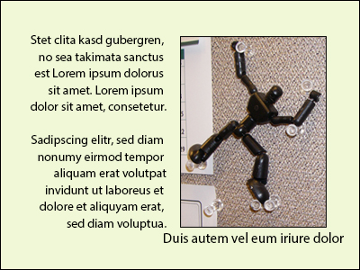
Question 2 options:
Use two lines for the label so it doesn't extend beyond the sides of the photo.
Make the paragraphs align on the left, not the right. Text should never align on the right.
Enlarge the photo so the model's feet align with the bottom of the text.
Move the photo and label up so the label lines up with the bottom line of text.

Question 3

Does this photo's alignment follow the rule of thirds?
Question 3 options:
No, the centre of attention should be near one or two invisible lines that divide the picture
into thirds.
Yes, there are three obvious parts to the photo: foreground, middle and background.
No, the city should take up a third of the picture, equal to the sky and water.
Yes, there are three sections to the photo: the sky, the city, and the water.

Question 4

Which if the following changes would improve the alignment of the Three Pigs slide? Choose all that apply.
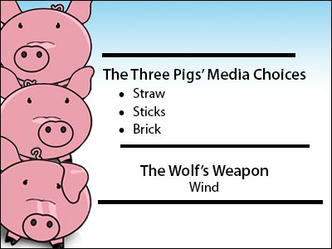
Question 4 options:
Use bold for all of the text.
Line up the left edge of the three lines and the two "The's."
Make the three lines the same length.
Don't centre the wolf information.

Question 5

Which statements describe how this photo's alignment follows the rule of thirds? Choose all that apply.
Question 5 options:
Three branches form three strong lines that are aligned and all point in the same direction.
The sky appears in the top third and most leaves are in the bottom two thirds.
The sky makes a spiral around the brightest yellow leaf, which is a third of the way from the
left edge.
The photo is made up of three main colours: blue, brown and yellow, and only one of those
colours stands out.

Proximity
Proximity means closeness. The design element proximity refers to grouping related things
close to each other, and using greater distance between things that do not relate.
In a PowerPoint slide with two lists that each has a title, we would be sure to position each title
close to its list; we would position the lists (and titles) farther from each other.
In a photo of a grandmother and her grandson in a park, an effective way to show their
relationship would be to position them close to each other. This helps clarify that only this
one little boy among all the children in the park "belongs" with the grandmother. Of course,
you could also create a photo where the little boy is exerting his independence by doing
something far from his grandmother, but you would have to use a different technique to
inform the viewer that the two people are related.
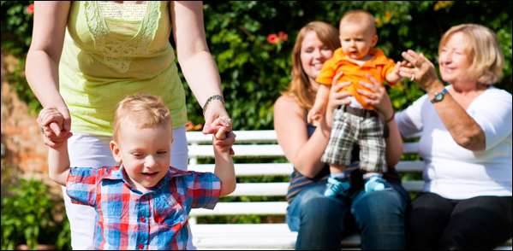
Follow the links below to see examples and uses of proximity:
- Design Basics: Proximity To Know What Belongs With What
http://vanseodesign.com/web-design/design-basics-proximity-to-know-what-belongs-with-what/
- The Principles of Graphic Design: How to Use Proximity Effectively
http://www.edgee.net/the-principles-of-graphic-design-how-to-use-proximity-effectively/

Once you feel that you understand the design element proximity, take a minute to do this self-assessment.
Answer the following questions to check your understanding.

Question 1
Which of these images uses the design element proximity most effectively?
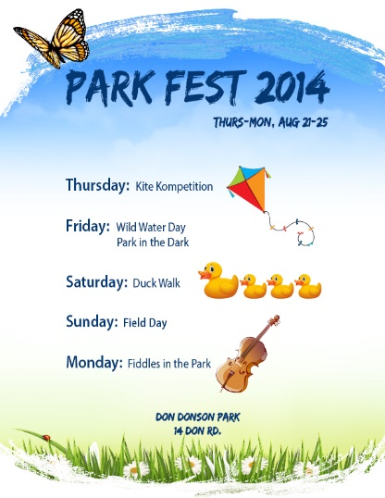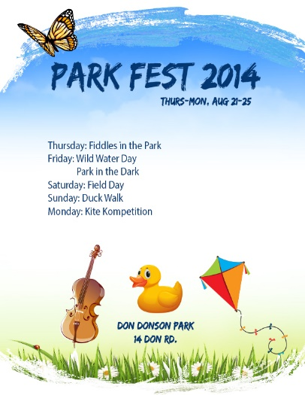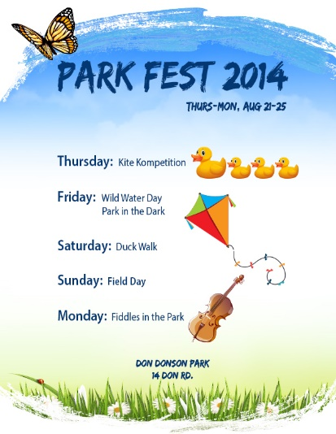

Question 2
Which of these images uses the design element proximity most effectively?
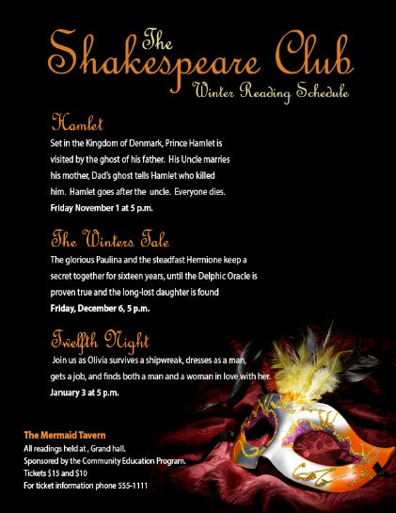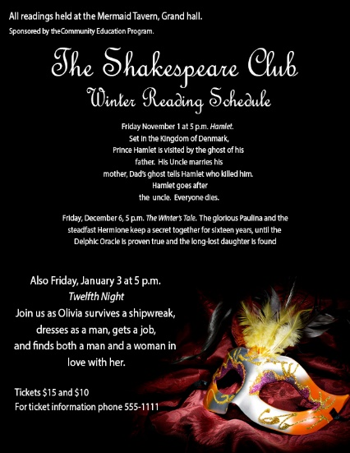

Question 3
Which of these images uses the design element proximity most effectively?
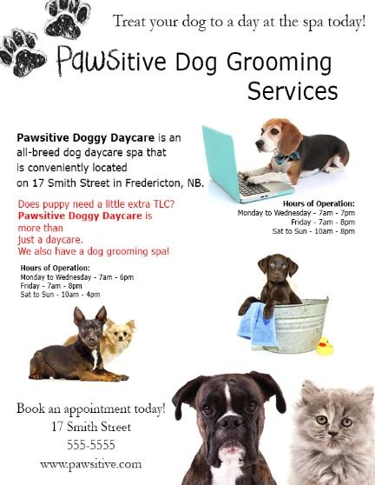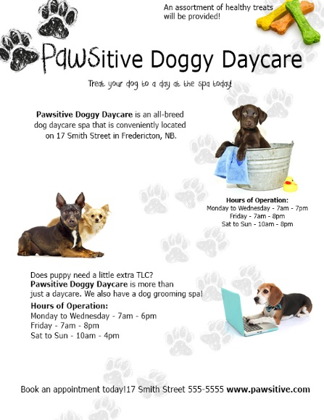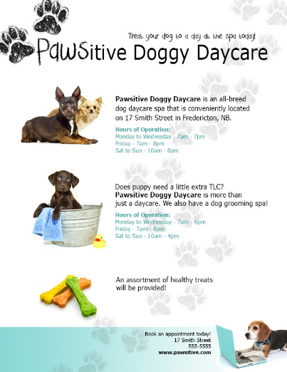

That concludes this discussion on CRAP (Content-Repetition-Alignment-Proximity)

