Carpentry – week 7

Building wooden houses involves attaching materials to other materials. Attachment can be achieved with nails, screws, and glues. The carpenter will select the method he will use based on the application and the materials.
Nails are often the preferred fastener for several reasons: ease of use, suitability, cost.
Nails are available in many lengths, weight and types and are applied with some type of hammer. Hammers can be manual or mechanical. One type of mechanical hammering devise is the pneumatic nailer (air nailer).
The common designations for these are:
Framing nailer
Finish nailer
Flooring nailer
Roofing nailer
Brad nailer
Pin nailer
Stapler

Here are some images, can you match the type to the image?

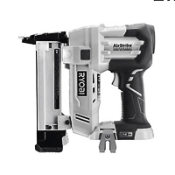 _____________________________

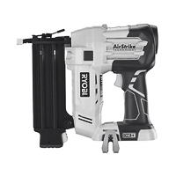 ___________________________________

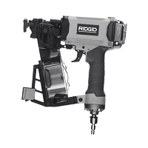 ___________________________________

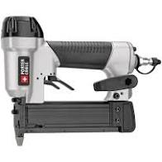 __________________________________
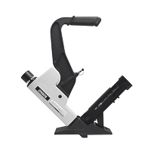 __________________________________
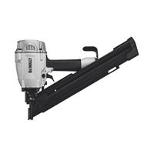 ___________________________________
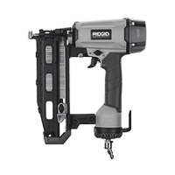 ___________________________________

Like all things, these are available in different quality and price ranges. Find the typical price range in Canadian dollars for each of these, both consumer and professional qualities.

What brands are typically available in Canada?

Where in Canada could you go to buy one?

These tools typically need to be energized with compressed air. The source can be from a compressor or from a compressed gas canister. Some are self contained in that the tool compresses its own air. However, most are energized by compressed air supplied by separate air compressor driven by an electric motor or a gasoline (could be diesel) motor.

By most common are electric motor air compressors. The capacity of the compressor needed is dependant on the nailer being used.

What size compressor is needed for each of type of nailer in the above list?

