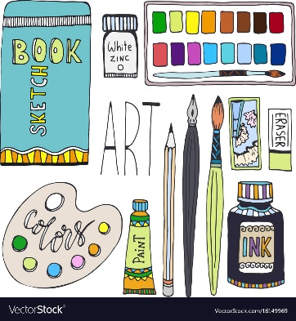
Visual Arts 10
Home Learning Checklist

Sketchbook Drawings (See Document tab for sketchbook sheet)

1, 2, 3 & 4. Already completed…so check off.
5, 6 & 7 Timeline suggestion: First week of May.
8, 9 & 10 Timeline suggestion: First week of June.

Alphabet Challenge (See Document tab for Instruction page)
Timeline suggestion: 2nd week of June
Art Idea Poster Page (See Document tab for Instruction page)
Timeline suggestion: 2nd week of June

Personal Challenge # 1__________________
See Document page for Instruction page.
Personal Challenge # 2__________________
Personal Challenge # 3__________________
Personal Challenge # 4__________________
Personal Challenge # 5__________________
Timeline suggestion: 2nd week of June

