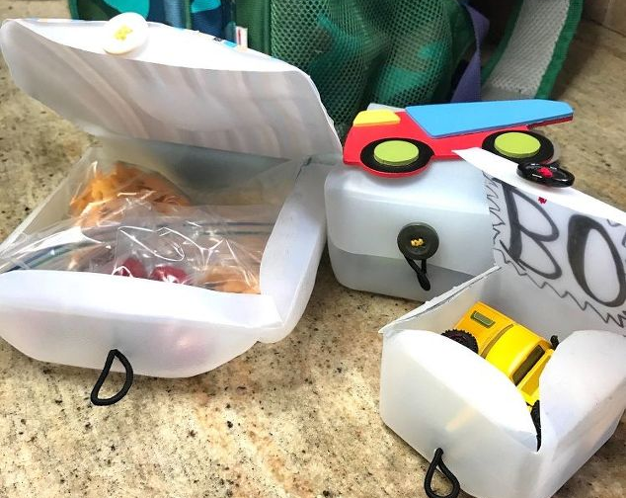
Visual Art 10
Recycled Art Project

The purpose of this project is to create an object that is either useful (such as a jar…) or decorative, using only items found at home. The objects used can be anything, as long as it is NOT newly purchased for this project!
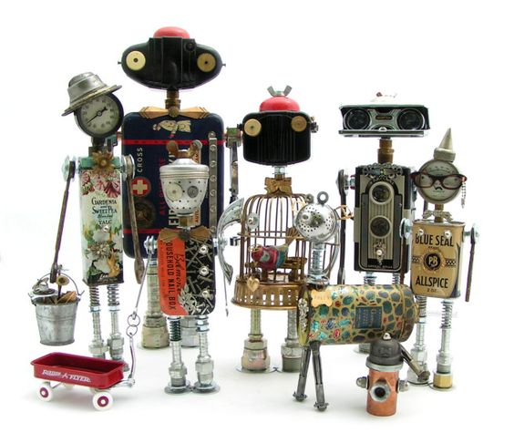
Go online to find ideas for your recycled project, please do not copy a project, but take ideas form several and put together to form your own signature piece. Below are some ideas of how items can be recycled. Timeline: to be completed by 2nd week of June.
Items used to create “robot” creatures. Tin cans, old tools, screws, nails, old broken odd items to use in decorating your creature.
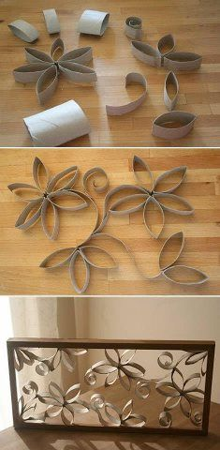
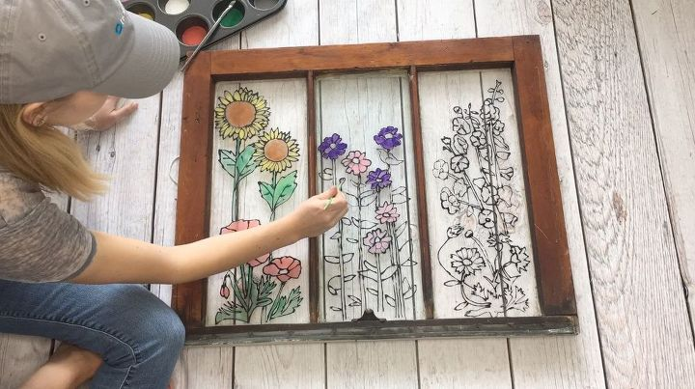
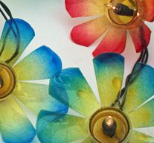
These are just some ideas of recycled art projects, the idea of this project is for you to assembly materials to create your own unique recycled creation, not to recreate someone else’s.
Remember to take three pictures.
1. Picture of the materials laid out on table.
2. Picture of your creation part way through the process.
3. Picture of your finished project
Send all three pictures to my email. Good luck and happy creating
Toilet paper rolls. Just used liquid glue to put pieces together. Create your own design.
An old window paint using liquid glue and liquid paint.
A string of flower lights. Water bottles cut, shaped and coloured and a string of lights added.

