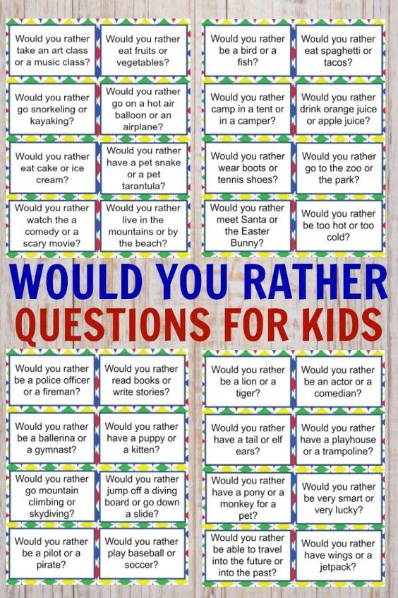

Here is another list for journal prompts you can use, HOWEVER, remember to explain why you choose what you did?

Why would you rather meet Santa over the Easter bunny? Explain please.

Remember Journal are 3 times a week, please pass in by Friday Noon.

Source:

<https://wondermomwannabe.com/would-you-rather-questions-for-kids/>