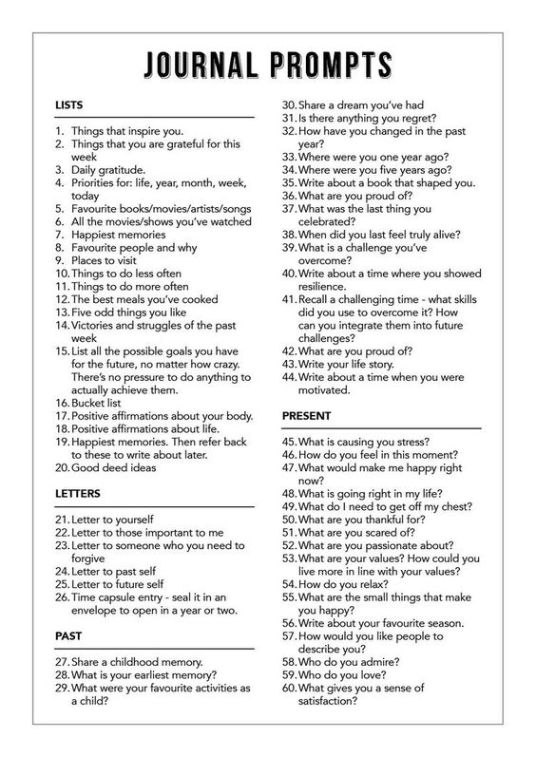
https://www.leuro.com.au/blog/2017/10/9/journalinghttps://www.leuro.com.au/blog/2017/10/9/jour
Source:
Source:https://www.leuro.com.au/blog/2017/10/9/journaling

