Blackout poetry

Blackout poetry is essentially blacking out the extra words from a page of text. The left over words on that page create the poem. Competition timeline: 2nd week of June. Please put name on work.
How to create a blackout poem:
Step1: Choose a page filled with print text.
Step 2: Circle the words that you feel would best express your concept/idea that you wish to express in a poetic form. Read the circled words a few times to ensure these are the words that you want to use.
Step 3: Here is where you can get creative in ‘blackening” out the rest of the text. At the end of this project are some examples of blackout poems styles. How you want to “present” your poem is a choice of personal style. In the blackout poem form, you are making a poem of the words available to you on the text page.
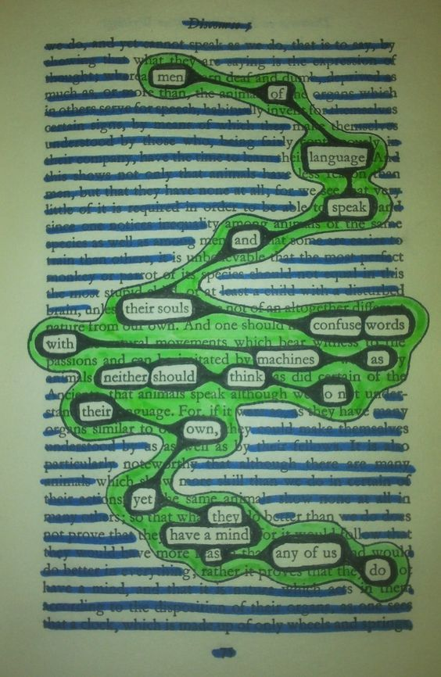
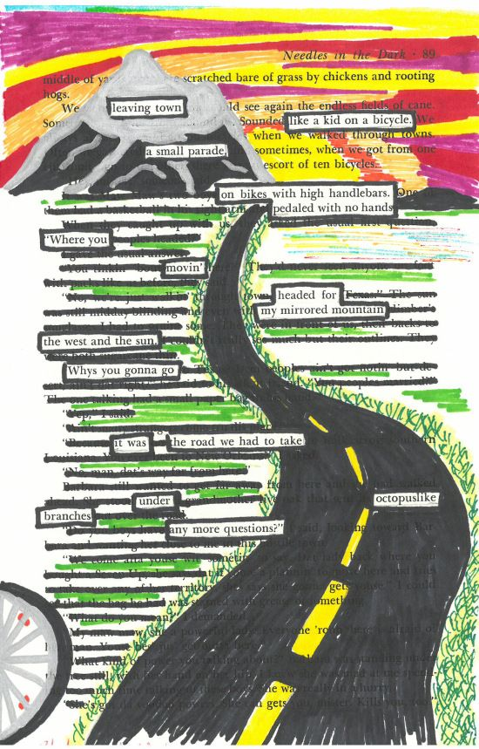
Try it and send me you blackout poem. Reflect on the process: easy,hard, too challenging? What aspect of the project did you like, not like? Send me your reflection also.
Examples of Blackout Poems:
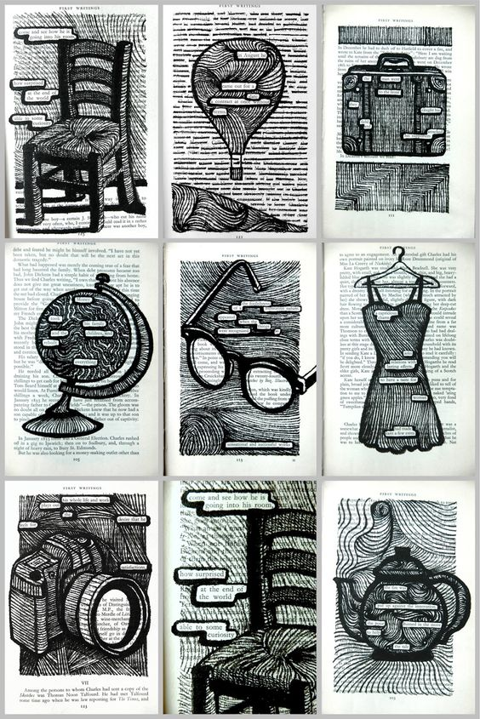
More examples of Blackout Poems:

