English 11-3 Personnel Challenge #1
Completion timeline: 2 week of June
You have experienced creating a black out poem. Think back to the tone, mood, or idea that you were trying to create; the challenge of selecting words to adequately create the image you wanted the reader to see/feel? Those same tools you will use in this challenge.
Listed on this page are elements used in creating a poem, they help the writer think of “what” and “how” they want to express. Also listed is a selection of poem “styles”, each style presents different challenges for the writer and the use/focus of the words used. Some “styles” work better with different topics than others, it is all about personnel choice. Have Fun with it! May I suggest researching a few different styles to see how those poems are written/constructed to help you understand how that style is used.
This challenge will ask you to create a poem from your own mind. Think of the following questions before/ as you create this poem:
What topic do you want to write about?
What voice do you want to use (first (I/me), second (you/your) or third (them/their)?
What poem “style” do you wish to use and why?
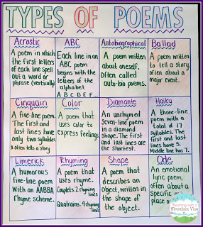
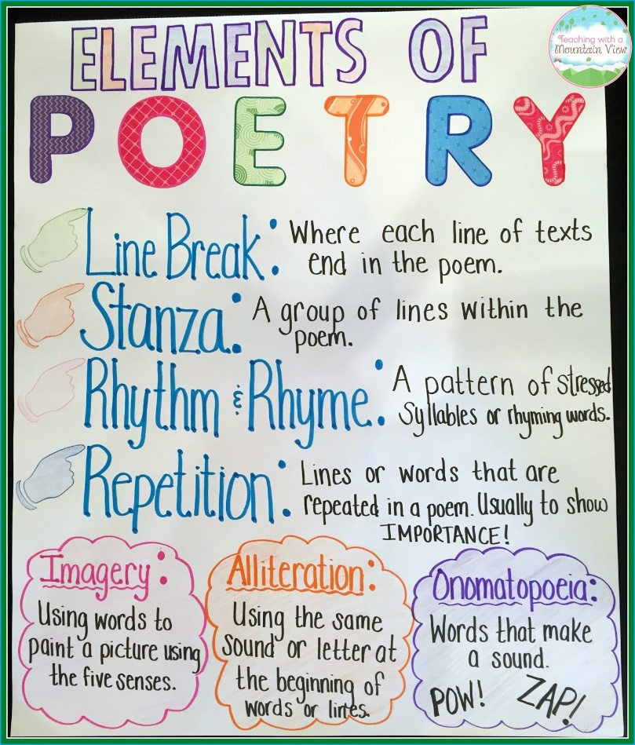
What challenge(s) did you experienced and what solution(s) did you use?
https://www.teachingwithamountainview.com/2015/08/the-best-anchor-chart-paper-ever.html

Ms.C examples of …
Haiku
Title: “Covid-19 despair”
Poem divided into syllables, you can see the break- down of the words.
Syllable count
Poem as seen by reader

Alone we all feel 5 syllables A/lone we all feel
Together but separate 7 syllables to/get/her but sep/er/ate
Longing for contact 5 syllables long/ing for con/tact

Acrostic
Topic:” Our class”
Together we make a class.
Each one different and unique.
Always striving to stretch and extend our skills.
Communicating our ideas to inform and challenge each other.
Helping fellow classmates achieve our potential.
The first letter of each line forms a word… T E A C H = TEACH. Remember that each line needs to reflect about the word you are spelling out.

Colour
The challenge is to use colour as a description of how a person is feeling, acting, or experiencing an event… it may take some researching of moods/feelings/ideas associated with colours before you write this poem.
It was fun for me and I’m sure you will have fun with your creation using colour( without having to paint!)
Perhaps you can describe an event that you experienced, recall the emotions and use colour to explain those emotions.
Title: “Confusion”
I’m so confused…
Am I sad, feeling so, so BLUE,
Am I angry, seeing nothing but RED,
Am I happy, sensing the sunshine of YELLOW,
Am I envious, feeling the jealousy of GREEN,
Am I gloomy, seeing only skies of GRAY,
Am I optimistic, seeing visions of WHITE,
Or am I pessimistic, sensing only valleys of BLACKNESS…
I’m so confused.

