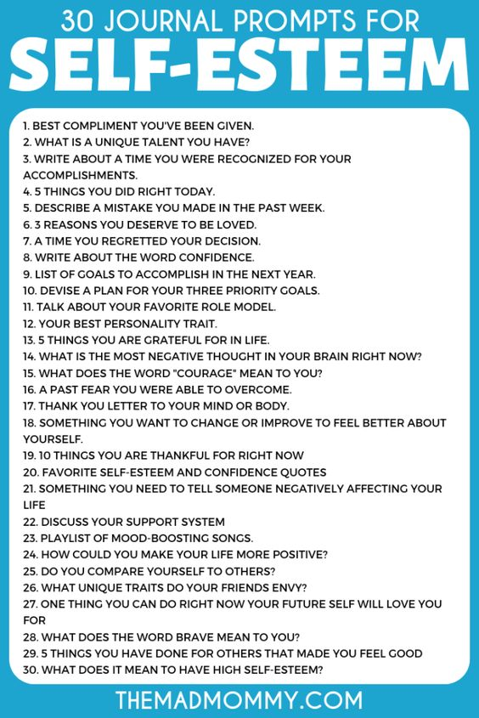

Any questions? Email me at [Brynn.cochrane@nbed.nb.ca](mailto:Brynn.cochrane@nbed.nb.ca) Mon-Fri: 9:00-11:30 and 1:00-3:00. Take a picture and send as an attachment for me to see your work in question.

You should be picking 4-5 per week. How you choose to present it is up to you, write, video, Power point, prezi… your choice. I miss you guys, stay safe and healthy….and wash your hands…a lot!!!

Good luck and see you soon.

English 11-3 Ms. Cochrane