**Conversion Factor/Formula Sheet**

Math 10

|  |  |  |  |
| --- | --- | --- | --- |
| **Imperial Conversions**  1 foot = 12 inches  1 yard = 3 feet  1 yard = 36 inches  1 mile = 1760 yards  1 mile = 5280 feet | | **Metric System**  km hm dam m dm cm mm  kL L mL  kg g mg   * Move to the right, decimal moves to the right * Move to the left, decimal moves to the left | |
| **Between SI and Imperial Units** | |  | |
| ***SI to Imperial***  1mm = 0.0394 in  1 cm = 0.3937 in  1m = 3.281 ft  1 m = 1.10936 yd.  1 km = 0.6214 mi | ***Imperial to SI***  1 in = 25.4 mm  1 in = 2.54 cm  1 ft. = 0.3048 m  1 yd. = 0.9144 m  1 mi = 1.6093km | ***Mass***  1 kg = 2.2 lb  454 g = 1 lb  2000 lb = 1 ton  2200 lb = 1 tonne = 1000 kg (metric tonne)  16 oz = 1lb  1 oz = 28.4 g | |
|  | | **1mL = 1cm3** | |
| **Converting US Imperial to SI Units** | |  | |
| ***US Imperial to SI***  1 fl oz = 29.5735 mL  1 pt = 16 fl oz  1 pt = 473.176 mL  1 pt = 0.473 L  1 qt = 2 pt  1 qt = 946.352 mL  1 qt = 0.946L  1 gal = 4 qt  1 gal = 3785.4 mL  1 gal = 3.785L | ***Imperial to SI $\frac{1}{4}$***  teaspoon(tsp) = 1.25 mL $\frac{1}{2}$ tsp = 2.5 mL  1 tsp = 5 mL  1 tablespoon (tbsp.) = 3 tsp  1 tbsp = 15 mL  1 cup = 250 mL  1 pint (pt) = 568.2614 mL  1 quart (qt) = 2 pt.  1 quart = 1.1365 L  1 gallon = 4 qt.  1 gallon = 4.5461 L | | ***Temperature*** |

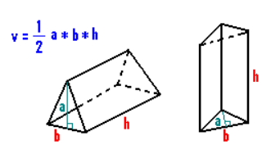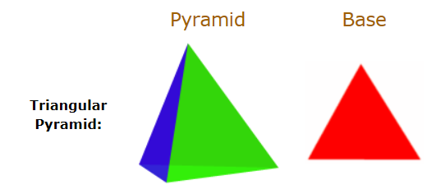****

Triangular Prism: